**‘I am the resurrection and the life.’**

**Reading:** John 11:17, 20-27

When Jesus arrived, he found out that Lazarus had already been in the tomb for four days.

When Martha heard that Jesus was coming, she went out to met him. But Mary stayed at home. “Lord,” Martha said to Jesus, “I wish you had been here! Then my brother would not have died. But I know that even now, God will give you anything you ask for.”

Jesus said to her, “Your brother will rise again.”

Martha answered, “I know he will rise again. This will happen when people are raised from the dead on the last day.”

Jesus said to her, “I am the resurrection and the life. Anyone who believes in me will live, even if they die. And whoever lives by believing in me will never die. Do you believe this?”

“Yes, Lord,” she replied. “I believe that you are the Messiah, the Son of God.”

**Thought about the reading**

Martha, Mary and Lazarus were brother and sisters and also friends of Jesus. One day Lazarus became very ill and died. When Jesus arrived, he had been dead for four days. Martha was very sad, because she thought that Jesus could have made him better if he had arrived earlier.

Jesus told her, “I am the resurrection.” Resurrection is when the dead come back to life. Jesus told her that Lazarus would come back to life. This is what happened! Jesus called to Lazarus and he came out of the cave where his body had been placed. He was alive and well again!

Jesus also came back to life. He died on the cross, and God brought him back to life. Lazarus grew old and died again, but Jesus will never die. He will live forever. This is why he said, “I am the resurrection and the life.” Those who follow him, even though they die in this world, will live forever in heaven with Jesus.

**Prayer**

Jesus, thank you that you give us new life. Thank you that you will give us life in heaven.

Please help us to say, like Martha, “Yes, lord, I believe.”

Amen

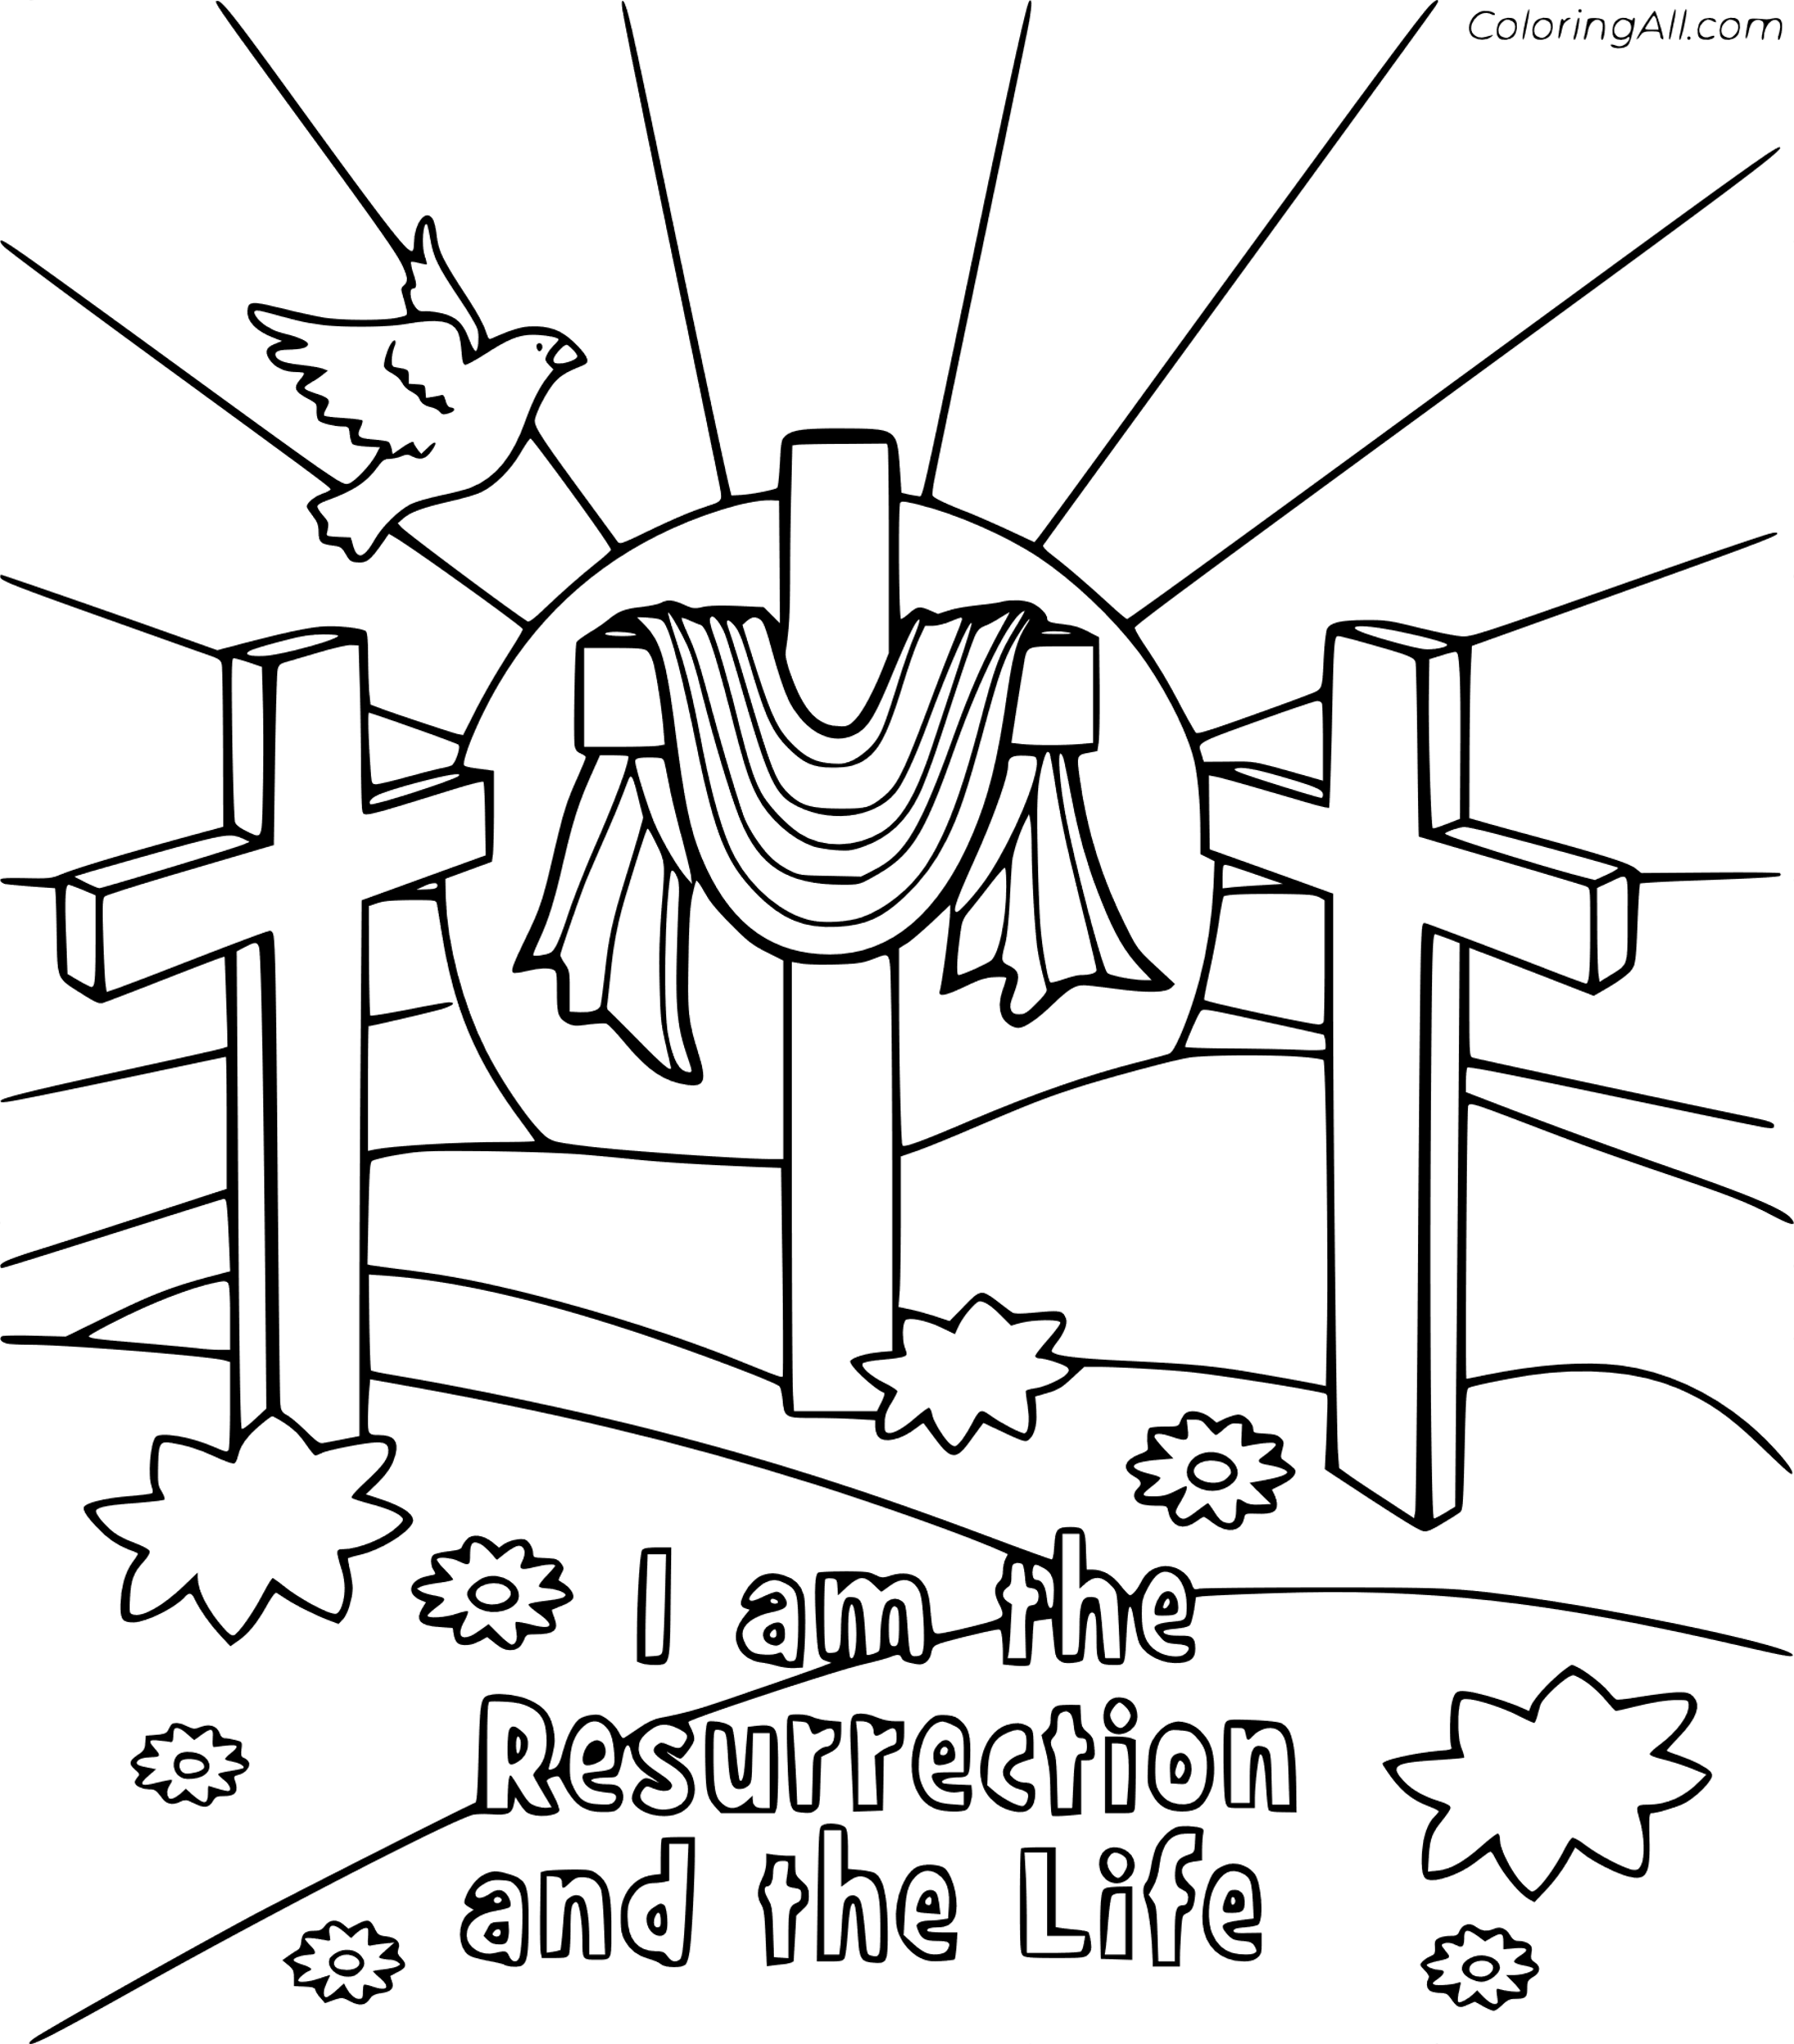

**Cambridge Causeway**

Autumn 2023

Bible Study notes

**Jesus said ‘I am…’**

**6. I am the resurrection and the life**

By Chrissy Cole